Children Services
Home to School Transport
Code of conduct for pupils and parents

January 2019

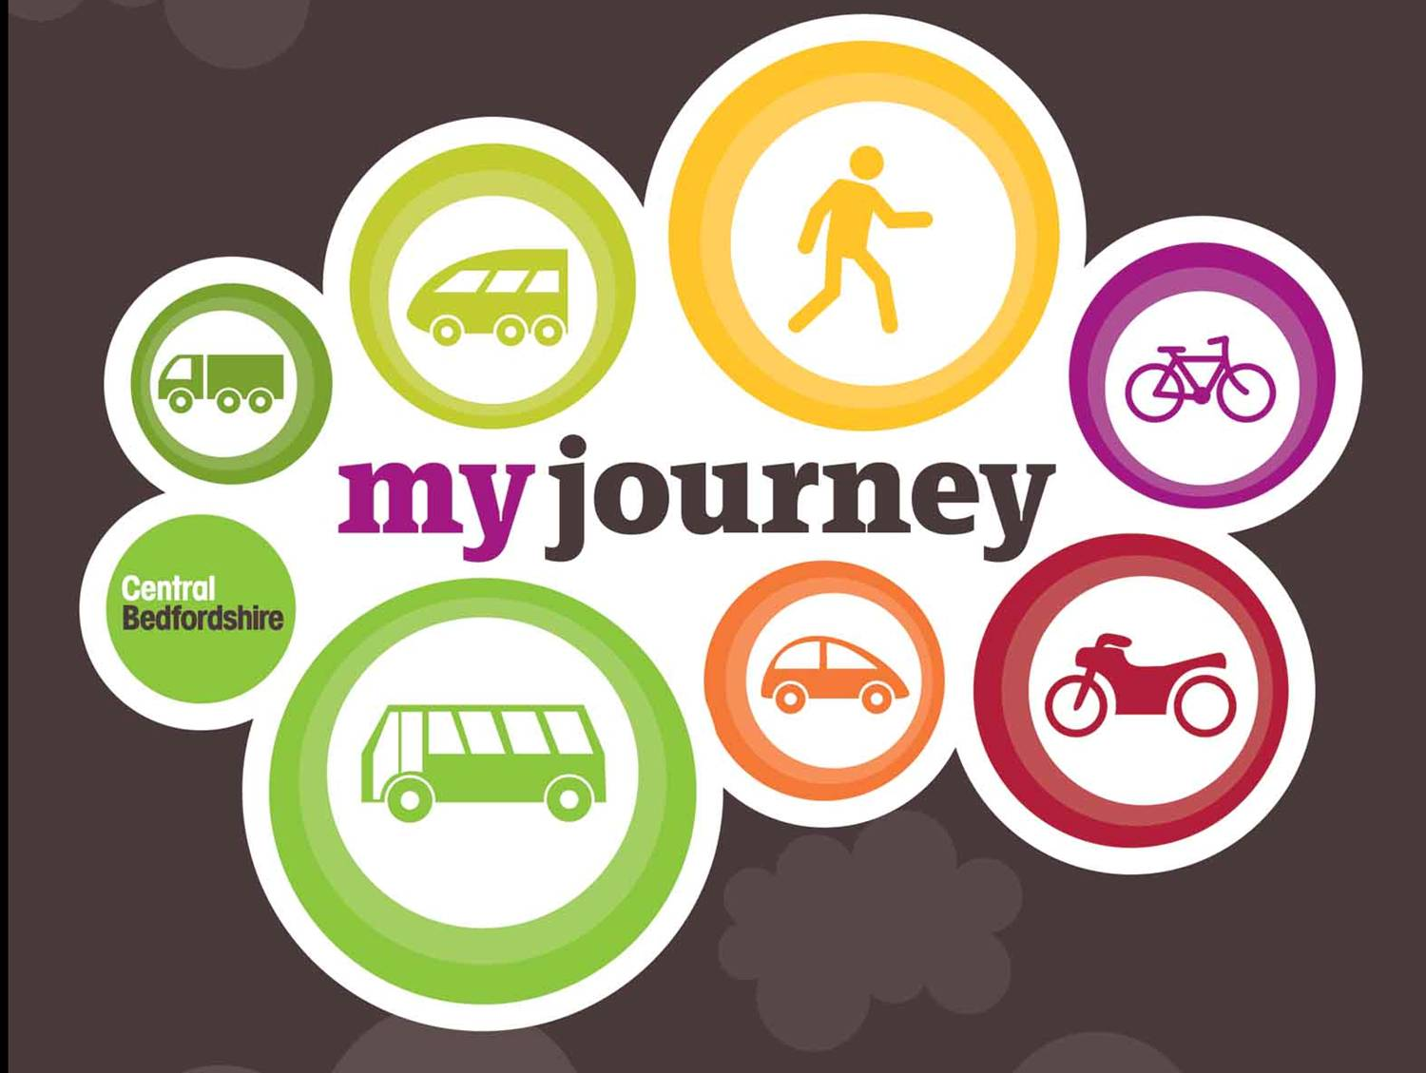

Transport Provision

Pupils entitled to travel to and from school under the current Home to School Transport Policy are provided with a journey at the beginning and at the end of each school day only, from a prearranged specified collection/drop off point. Alternative collection/drop off points will not be authorised.

The safety and comfort of pupils travelling on home to school transport routes is of the utmost importance. The Council is constantly looking at ways to improve quality and safety standards on all routes. Current standards include:

- CCTV on all vehicles of 30 seats or more
- Seatbelts on all vehicles
- Risk assessment of stops, routes and services
- Continuous monitoring of the service
- Behaviour management including consultation with schools
- Written confirmation to schools of any changes in the provision of transport
- This Code of Conduct

Why is there a Code of Conduct?

The Code of Conduct exists to make the journey between home and school safe and comfortable for all those travelling. The Council’s priority is to meet all health and safety requirements and to avoid accident or injury wherever possible. This document has been produced in line with the Home to School Transport Policy.

The Code of Conduct

In order to ensure safe travel to school, pupils should always:
- Wait sensibly for the bus, off the road, in a safe area/designated stop
- Be at the stop at least 5 minutes prior to the specified collection time
- Have their bus pass ready to show the driver; failure to do so may mean they will not be able to travel
- Maintain their bus pass in a good condition. Damaged passes will not be accepted by the driver and travel may be refused
- Be polite, courteous and respectful to the driver, passenger assistants and all other passengers
- Remain in their seat whilst the vehicle is moving
- Wear a seatbelt (where provided)
- Put belongings safely out of the way and keep the gangway clear
- Leave the bus clean and tidy – take rubbish away and deposit in a waste bin
- Follow any instructions given by the driver or passenger assistant
- Make an agreement with parent/carer as to what to do if the bus does not arrive or is missed
  - If there is an accident pupils should stay on the bus until advised otherwise by the driver/passenger assistant. If it is unsafe to stay on the bus the driver/passenger assistant will inform pupils of the appropriate action. If pupils leave the vehicle without the drivers permission this will be reported to the school and where possible to the parent/carer.

Pupils should never:
- Allow another pupil to use their bus pass
- Distract the driver
- Operate the doors or emergency exits unless there is an actual emergency
- Deliberately damage or vandalise the vehicle
- Throw items around inside or out of the windows of the vehicle
- Smoke, eat or drink whilst on the vehicle
- Intimidate or be verbally or physically abusive towards other passengers, the driver or passenger assistant
- Cross the road in front of or immediately behind the vehicle.
- Leave the vehicle without permission

What can happen if the Code of Conduct is not followed?

Penalty guidelines
If an incident occurs it will be investigated jointly by the School, Contractor and Central Bedfordshire Council with the use of CCTV footage (if available) and witness statements. Failure to adhere to the Code of Conduct will result in the issuing of a warning and/or a ban determined by the frequency and/or the level of offence.

Any transport ban implemented will be supported by the School and notice will be provided to the Parents/Carers. It is parental responsibility to ensure that their child continues to attend school during any ban from home to school transport.

The below are guidelines only and penalties will vary dependent upon each individual incident. They include but are not limited to the following:

Category 1 (warning or withdrawal from transport)
- Not wearing a seatbelt (where provided)
- Swearing at the driver/passenger assistant/general public
- Disobeying an instruction given by the driver and/or passenger assistant
- Littering the vehicle
- Misuse of the bell
- Refusal to remain seated whilst the vehicle is in motion.

Category 2 (short term withdrawal from transport)
- Lack of consideration towards driver/passenger assistant/member of the public
- Minor vandalism
- Smoking
- Verbal abuse towards driver/passenger assistant/other passengers
- Repetition of any incident which resulted in a ban
- Interfering with safety equipment
- Distracting the driver by moving around the vehicle whilst it is in motion.

Category 3 (long term or permanent withdrawal from transport)
- Misuse of emergency exit and windows
- Misuse of main entrance door
- Bullying or harassment
- Assault of another passengers/driver/passenger assistant both physical & verbal
- Intentionally distracting the driver
- Throwing objects around inside or out of the vehicle
- Pushing others through doors or windows
- Serious acts of vandalism.

Those students who choose to repeatedly act in a manner that is detrimental to the safety and well-being of others may be permanently excluded from transport.

Information for parents/Carers

By accepting the transport provision from Central Bedfordshire Council you are agreeing to the Code of Conduct and to advise the School Transport Team of any changes in contact details or circumstances that may affect the provision of transport for your child.
If a parent/carer verbally abuses a driver or contractor your child may receive a warning or ban for your behaviour.

Declaration from Central Bedfordshire Council
Central Bedfordshire Council reserves the right to issue warnings and/or ban students whose behaviour is deemed to cause offence or which puts themselves or others at risk. Pupils enter an agreement with Central Bedfordshire not to act in a manner which is likely to cause harassment, alarm or inconvenience to other transport users. Pupils should also understand that breaching the Code of Conduct will result in action being taken in line with published penalty guidelines. In additional a pupil’s entitlement to transport may be removed.

If transport was withdrawn Parents/Carers would be responsible for arranging alternative transport for their children. Where the transport company incurs a cost for repair of loss of service following Vandalism to the vehicle this cost will be passed on to parent/carer of the student proven responsible.

Whilst Central Bedfordshire Council aim to keep changes to your child’s transport to a minimum, it is necessary to make regular reviews of the transport network to ensure the Council is providing a cost effective and appropriate service. Where changes are made Central Bedfordshire Council will endeavour to provide written confirmation to the pupil’s home address or via the school.

If you have any concerns about the transport provision that your child is receiving please do not hesitate to contact us.

Contact us…
Telephone: 0300 300 8339
Email: school.transport@centralbedfordshire.gov.uk
web: www.centralbedfordshire.gov.uk
Write to: The School Transport Team, Central Bedfordshire Council, Priory House, Monks Walk, Chicksands, Shefford, Bedfordshire, SG17 5TQ

