Where can Geography
take you?
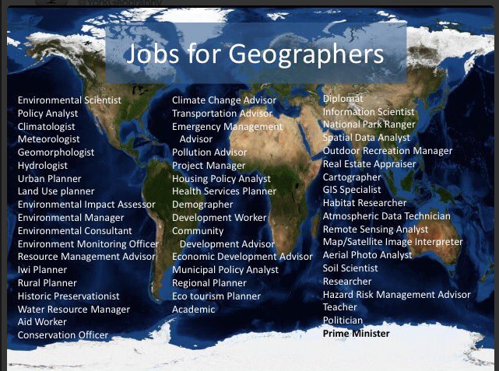

University and Careers

Geography is very much recognised as a subject of today and the future. As the need for more sustainable development increases, Geographers are very much in need, whether it is in urban planning, flood management, or climate change. Geography is offered at all the top universities, including Oxbridge. As the only subject that transverses both the sciences and the arts, Geographers develop a good all-round skills base which enables them to follow numerous careers.

