Edexcel Geography – ‘Thinking Geographically’
A Level
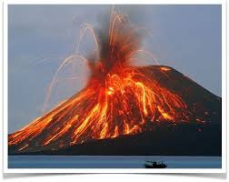
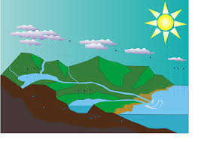

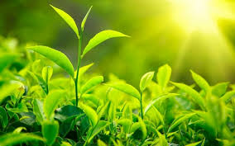
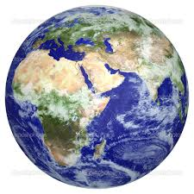
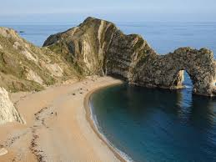

Course Guide 2020 – 2021
Course text books to purchase:
- Edexcel A Level Book 1 Geography by Dunn, Adams, Holmes, Oakes, Warn, Witherick - Hodder Education, ISBN 978-1-4718-5654-9
- Geography for Edexcel A Level Year 1 by Digby, Adams, Chapman, Hurst – OUP, ISBN 978-0-19-836645-4
- Edexcel A Level Geography Book 1 - Pearson, 978-1-29215325-4

Course Overview
Year 1
Area of Study | Summary of Content
1 - Dynamic Landscapes | Topic 1: Tectonic Processes and Hazards  Topic 2: Landscape Systems, Processes and Change – 2B Coastal Landscapes
2 – Dynamic Places | Topic 3: Globalisation  Topic 4: Shaping Places – 4B Diverse Places
Year 2
Area of Study | Summary of Content
3 – Physical Systems and Sustainability | Topic 5: The Water Cycle and Water Insecurity  Topic 6: The Carbon Cycle and Energy Security
4 – Global Development and Connections | Topic 7: Superpowers  Topic 8: Global Development and Connections – 8B Migration, Identity and Sovereignty

Assessment Overview
All assessment will be carried out at the end of year 2
Topics | Exam | Weighting | Content
Paper 1  Physical  Topics 1, 2B, 5, & 6 + geographical skills | 2 hours 15 mins | 105 marks  30% of A level | Candidates to answer all questions based on topics studied (not 2A). The examination may include short open, open response, and resource linked questions. It includes 12 and 20 mark extended writing questions.
Paper 2  Human  Topics 3, 4B, 7, 8B + geographical skills | 2 hours 15 mins | 105 marks  30% of A level | Candidates to answer all questions based on topics studied (not 4A/8A). The examination may include short open, open response, and resource linked questions. It includes 12 and 20 mark extended writing questions.
Paper 3  Synoptic investigation  Resource booklet provided with information about a geographical issue rooted in 2 or more of the compulsory areas of study (1, 3, 5, 6, 7). Focus is on synoptic themes of  - Players  - Attitudes and actions  - Futures and uncertainties | 2 hours 15 mins | 70 marks  20% of A level | Candidates provided with resource booklet at start of exam. Candidates to draw synoptically on knowledge and understanding from compulsory content from different parts of course.  The examination may include short open, open response and resource linked questions, It includes 8, 18, and 24 mark extended writing questions
4 – Coursework (NEA)  Non examined assessment  Independent Investigation | Completed over the 2 years of study | 70 marks  20% of A level | Candidates to carry out at independent investigation focused on any part of the course studied throughout the 2 years.  The investigation is internally assessed and externally moderated.  The written report should be between 3000 - 4000 words.
Timetable for year 1
- One teacher for each class will be teaching the Human content for Paper 2 (topics 3 and 4). Another teacher for each class will be teaching the Physical content for Paper 1 (topics 1 and 2)
- Topic 3 skills will be covered throughout the content with other Geographical skills.
- Fieldwork skills will be incorporated in to topics 2B and 4B throughout the year, with local and residential fieldwork activities planned to help embedded the fieldwork skills
- The independent investigation will be addressed throughout the course with specific periods of time to focus on the gathering of data and writing up of the investigation.
- We are going on fieldwork to Orielton in Pembrokeshire, South Wales during March 2021 (providing COVID 19 is over). The cost for this in the past has been between £350 and £400. There is a requirement in the exam specification for all students to complete 4 days of fieldwork. There will be opportunity for local day visits as well.
Progression into year 13
- You will sit your Internal Progression Examinations (IPE’s) towards the end of year 12, assessing you on the topics and skills studied throughout the first year.
- If a U or E grade is achieved in the end of year 12 geography IPE along with U and E grades prior to the IPE, you will be advised not to continue into year 13 with geography.
How to achieve your best grade
Here is a list of tips (some more obvious than others) to help you succeed:
- Attendance
  - Aim for 100% attendance, but if you are away, make sure you copy up missed work
  - All of the lesson notes, powerpoints and resources are available on the Sixth Form Learning Platform which is accessed on the Google Drive.
- Homework
  - Make sure it is completed and keep to deadlines
- Go over notes
  - Read through class notes and highlight key points. Ask your teacher if points need clarification.
  - If you don't get it first time, remember – Brain, Book, Browser, Buddy, Boss (in that order).
- Making the most of prep time and free periods
  - Find somewhere quiet to work.
  - Use the 6th form study spaces wisely.
  - All Geography rooms are available for any Geography student to use if they are free, just ask one of the teachers first. The computers in 415 can be used, and the study room in the corner of 415 is available for sixth formers as a quiet work area.
  - Text books can be found in classrooms. You are welcome to use them when they are not being used in a lesson, please use them in the department and don't walk off with them. We strongly advise you to get your own copy; it will make a big difference to how much extra reading you can do.
  - There are chromebooks kept in the Geography department – again, feel free to use one up in the department if you would like to, again check with one of the teachers first.
- Thinking Geographically
  - Geography is a subject that is constantly changing and you need to stay aware of what is going on around the world and make links between different aspects.
  - Watch the news, read newspapers, use sites like www.bbc.co.uk to stay up to date with everything going on.
  - Most importantly, follow us on Twitter @Samwhitgeog where we regularly tweet relevant articles and materials, along with important information related to the department and fieldwork.
  - Complete MOOCs to extend your learning.

- Past paper practice
  - As this is a new qualification, there is a limited amount of past papers available to you. Stay up to date though through http://qualifications.pearson.com/en/qualifications/edexcel-a-levels/geography-2016.html with any available resources for the new qualification.
- After school and lunchtime sessions
  - You will be offered the opportunity to attend extra sessions and revision lessons as certain times during the year. Don’t let these opportunities escape you!
Other opportunities
- You may like to consider studying Geography at university. Geography is one of the few subjects which traverse science and the arts. From Physical, to Environmental, to Human Geography, the different types of Geography you can study at university are endless. Refer to the Key Stage 5 information board in 415 and www.ucas.ac.uk for further information.
- There will be an opportunity in year 12 to become a ‘Geography Ambassador’. This will be a chance for you to represent your subject and take part in different activities relating to it. Take an opportunity like this will look excellent on your applications for university, apprenticeships, and jobs in to the future.
- We encourage all our geography students in year 12 to take part in the numerous opportunities that the Royal Geographical Society offer such as the RGS Essay competition and geographer of the year.
Summer Homework
Complete the following before your return in September. You have studied Tectonics previously at GCSE so you are developing your knowledge and understanding further rather than studying something completely new. Any questions about the work, please email lhuckle@bestacademies.org.uk, trowell@bestacademies.org.uk or jhatchell@mybest.org.uk BEFORE Friday 17th July – after this, we can’t guarantee when we will respond.
Produce detailed notes and diagrams on the following aspects for the PHYSICAL paper:
- Earth’s structure
  - Layers
Up your game!
- Use A level terminology
- Start a ‘key terms’ list with definitions
- Put work in to your own words – don’t just copy
- Learn it!
- Be prepared to use it on your return in September
  - Properties
  - Convection currents
- The theory behind continental drift
  - Wegener’s theory
  - Biological evidence
  - Climatological evidence
  - Geological evidence
  - Palaeomagnetism
- Plate boundaries
  - Constructive (divergent)
  - Destructive (convergent) - Subduction (oceanic + continental, oceanic + oceanic)
  - Destructive (convergent) - Collision
  - Conservative
Produce detailed notes and diagrams on the following aspects for the HUMAN paper:
Topic 1 – GLOBALISATION
- Produce detailed notes and on the following aspects
  - What is globalisation?
  - Causes of globalisation
  - How does free trade increase globalisation?
  - What is the International Monetary Fund (IMF)?
  - What is the World Bank?
  - What is the World Trade Organisation (WTO)?
Undertake a MOOC at:
https://www.futurelearn.com/courses/categories/nature-and-environment-courses
https://www.futurelearn.com/courses/categories/politics-and-the-modern-world-courses
- They are free (online certificate available)
- They add to your future job or university applications
- 6th Form will be asking you to do them anyway – get ahead of the game
- There are a range of relevant topics to your Geography studies.
Notes:

