BTEC Level 3 National Extended Certificate in Health and Social Care

Student Handbook
2019/20

Student name
______________________

Contents

Introduction to the course:
- Introduction
- Course Aims
- Career Considerations

Expectations

Interventions

Use of Praise

How will you be assessed?

Externally assessed units

Internal assessed units

Synoptic assessed units

Course Structure

Overview of units

Mandatory and Optional units

Grading
- Distinction/ Merit/ Pass/ Unclassified

Points score system

Submissions
- Resubmissions

Useful information you should know

Plagiarism

Website to Course Specification

Recommended Textbooks

Email addresses of subject teachers
Introduction to the Course
Introduction:

- The Health and Social Care Department run the course.
- This includes; Miss Blessing, Mrs Chamberlain and Mrs West.
- This qualification is equivalent in size to one A level
- You learn by completing projects and assignments that are based on realistic workplace situations, activities and demands.

Course Aims:

- The Pearson BTEC Level 3 National Extended Certificate in Health and Social Care aims to provide an introduction to the sector. It is for students who are interested in learning about the health and social care sector as part of a balanced programme of study.
- This qualification has been designed to support profession to higher education when taken as part of a programme of study that includes other appropriate BTEC Nationals or A levels.
- This qualification gives learners the opportunity to gain a broad understanding and knowledge of the health and social care sector, as well as develop a range of personal skills throughout the selection of units that are essential for successful performance in working life.

Career Considerations:

- Some of our students progress to study various health and social care disciplines at university such as medicine, nursing, social work, midwifery and physiotherapy.
- Others undertake Child care courses at local colleges or combine in working alongside an apprenticeship scheme.
- Some students take the knowledge and skills they have obtained in Health and Social Care to work in armed forces and emergency services.

Expectations
The following is expected of every student studying this course:

- To actively engage yourselves in all theoretical aspects of the course
- To show high levels of commitment in achieving your very best
- To develop personal qualities: leadership, responsibility, self-discipline, high standards, commitment and teamwork.
- Manage your time effectively to achieve objectives and to gain a variety of skills – Organisation is key!
- Work well with others but also discipline yourself when working alone
- Meet all deadlines set and hand assignments in on time
- Ask for advice & help where needed

Interventions:

To ensure every student achieves their full potential the Health and Social Care Department and 6th form will use the following strategies:

- Regular attendance checks
- Phone calls home
- Academic referrals
- BTEC catch up sessions
- Meetings with KS5 leader
- Subject report
- 6th form contract

Use of Praise:

To recognise the hard work and commitment of individual students who continuously show high levels of dedication to achieving their very best, we will be:

- Verbally praising you for your efforts in lesson
- Sending postcards home/ Praise badges
- Highlighting personal achievements in your subject report
- Speaking to parents via phone calls home/ PRE appointments
- Nominating you for a subject award

How will you be assessed?

- You will be assessed in four separate units, three of which are mandatory units and two are external. The Mandatory content makes up 83% of the qualification while the external assessments are 58%.

- Externally assessed units – Unit 1: Human Lifespan 1.5 hours 90 marks and
Unit 2: Working in Health and Social Care is 1.5 hours 80 marks

- Internally assessed units - you must complete at least one optional unit (10, 11, 12 or 14), all of which are internally marked and require you to submit evidence towards a given assessment criteria. This means that the teacher delivering the unit sets and assesses the assignment that provides the final summative assessment of each unit.

- Synoptic assessment (Unit 5) - Synoptic assessment is one that you would take later on in their programme of study, to which they will be expected to apply learning from a range of units. Synoptic units may be internally- or externally assessed.

Course Structure (360 GLH)

- Mandatory units - There are 3 mandatory units, 1 internal and 2 external. Learners must complete and achieve at pass grade or above for all these units.
- Optional units - Learners must complete at least 1 optional unit.

Unit | Mandatory Units | Assessment | GLH
1 | Human Lifespan and Development | External | 90
2 | Working in Health and Social Care | External | 120
5 | Meeting Individualised Care and Support Needs | Internal  *Synoptic* | 90

Unit | Optional Units | Assessment | GLH
10 | Sociological Perspectives | Internal | 60
11 | Psychological Perspectives | Internal | 60
12 | Supporting Individuals with Additional Needs | Internal | 60
14 | Physiological Disorders and their care | Internal | 60
Please note: The total units over the two years = four units
Grading

- As part of each unit and the assessment it entails you will be graded with a Distinction, Merit, Pass or Unclassified.
- Students must complete and achieve at least a pass grade or above in at least one optional unit.
Points available for external units

Overall grade | Unit Size
 | 60 GLH | 90 GLH
U | 0 | 0
Pass | 9 | 12
Merit | 15 | 20
Distinction | 24 | 32

Points available for internal units

Overall grade | Unit Size
 | 60 GLH | 90 GLH
U | 0 | 0
Pass | 6 | 9
Merit | 10 | 15
Distinction | 16 | 24
Submissions

Each assignment will indicate a submission date. The work must be handed in to
your teacher in the specified lesson. Teachers have the right to refuse to mark
your work if work is not handed on time.

All work must be submitted with a completed Learner assessment submission and declaration form. See below

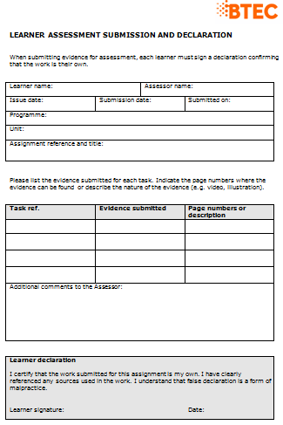

Resubmissions:
Resubmissions will be authorised if you have met the following criteria:
  - The learner has met initial deadlines set in the assignment, or has met an agreed deadline extension.
  - The tutor considers that the learner will be able to provide improved evidence without further guidance.
  - Evidence submitted for assessment has been authenticated and accompanied by a signed and dated declaration of authenticity by the learner.

**Any resubmission evidence must be submitted within 15 working days

Useful information you should know

Plagiarism:

In the event of a student copying and submitting the work of another student the following procedure will take place.

- The assignment will be classified as a referral, and have to be resubmitted by a given deadline.
- A written warning will be handed to the student
- If the offence is committed again then the student will be withdrawn from the course.

- Access to the Course Specification

http://qualifications.pearson.com/content/dam/pdf/BTEC-Nationals/Health-and-Social-Care/2016/specification-and-sample-assessments/9781446938003_BTEC_Nat_ExCert_HSC_AG_Spec_Iss3C.pdf

- Recommended Textbooks

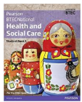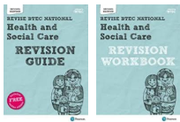

- Subject teacher emails

kblessing@bestacademies.org.uk
kchamberlain@bestacademies.org.uk
cwest@bestacademies.org.uk

