AQA GCSE English Literature text books and revision guides
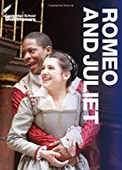
Romeo and Juliet (Cambridge School Shakespeare)
ISBN: 978-1-107-61540-3
This is a great edition that we use in class. It has summaries of each Act and Scene. It also breaks down key parts to help aid your understanding.

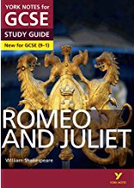
Romeo and Juliet: York notes for GCSE (9-1)

I can’t recommend these revision guides enough. They are full of fantastic revision resources, model writing and a breakdown of plot, characters and key themes and context.

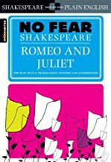
Romeo and Juliet (Sparknotes No Fear Shakespeare)
ISBN: 978-1-58663-845-0
Struggling with the language? This has a modern translation for every single line of the play! I would really recommend this if you are struggling with understanding Shakespearean language.

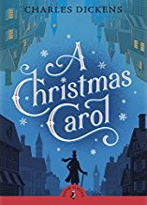
A Christmas Carol (Puffin Classics)
ISBN: 978-0-141-32452-4
Having a copy of your own text enables you to highlight and annotate ideas whilst we are reading in class. Although you are unable to take this into your final exam, it will be a fantastic revision resource.
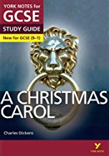

A Christmas Carol: York Notes for GCSE 9-1 ISBN: 978-1-4479-8212-8
£5.99 I can’t recommend these revision guides enough. They are full of fantastic revision resources, model writing and a breakdown of plot, characters and key themes and context.
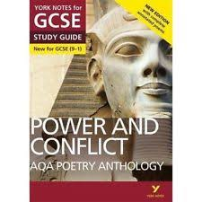

AQA Poetry Anthology - Power and Conflict York Notes for GCSE 9-1
ISBN: 978-1-292-23031-3

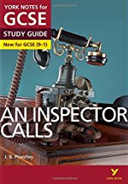
An Inspector Calls: York Notes for GCSE 9-1
ISBN: 978-1-4479-8216-6
I can’t recommend these revision guides enough. They are full of fantastic revision resources, model writing and a breakdown of plot, characters and key themes and context.

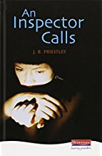
An Inspector Calls
ISBN: 978-0-4352-3282-5

